Stacked Rapid Sand Filtration
Final Report, Spring 2011

Part 1: Siphon Filter Control System

Procedures

The proposed mechanism for controlling flow to each layer of the full-scale SRSF is a siphon system. This control system is illustrated conceptually in Figure 1. If it can be successfully employed, it will significantly simplify the operation of the SRSF by replacing seven valves (one for each layer) with one air valve on the siphon.

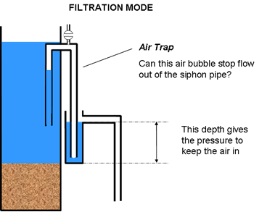

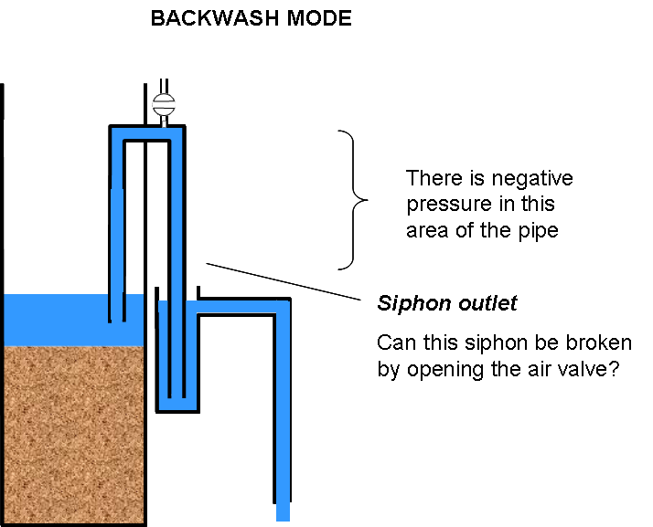
Figure 1.1 Conceptual diagram of the SRSF siphon control system, showing heights of water during the filtration and backwash modes of operation.
The hydraulics of this control system were demonstrated at the bench scale. The important components of this system were simulated using:
- A bucket to represent the water space over the filter, with arbitrary target water levels for filtration and backwash.
- A smaller container for the backwash outlet channel
- A tube to set the “filtration mode” water height in the bucket
- A siphon with 3” clear PVC pipes so flow inside could be observed, and adaptors to connect a ½” air valve

Relative heights of water appear to be the most important factor governing operation of this system. Therefore, as experiments were run, a number of heights were measured relative to an arbitrary datum (the laboratory counter), as illustrated in Figure 2.

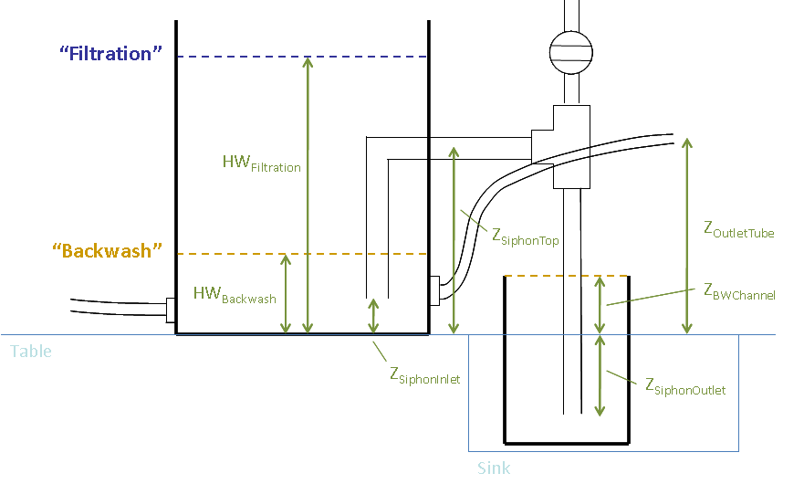
Figure 1.2. Experimental siphon system, showing heights measured during each test.

Results and Discussion

The siphon system is a viable concept overall. The major phases of operation were successfully demonstrated, including:
- Stopping flow out the siphon pipes with an air trap in the siphon.
- Releasing the air trap to switch into backwash mode.
- Breaking the siphon to switch back into filtration mode.
Generally, the mode of operation can be changed at any time by opening the air valve, which is the intent of the system design.
Several important design heights were observed, as shown in Figure 3:

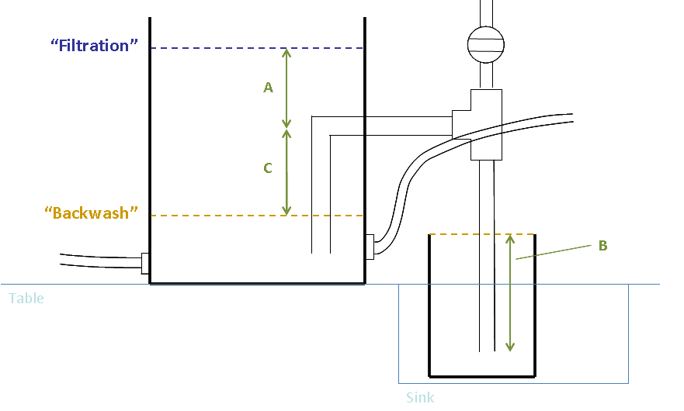
Figure 1.3. Important heights controlling failure modes of the siphon control system.

Phase (1) was controlled by the A/B ratio – that is, the end of the siphon pipe must be submerged a sufficient depth B in the backwash outflow channel to “hold up” a height of water A with the air trap. This ratio was observed to be about 0.6 to 0.7 at system failure, above which water would begin leaking through the siphon. This suggests that if 30 cm of head loss rise are desired during filtration, 42 cm of submergence must be provided in the backwash channel.

Phase (2) is easily accomplished, and takes place in a matter of seconds. Air escapes quickly through the air valve or out through the backwash channel, and the siphon tube fills with water once the valve is closed. No failure condition was observed.

Phase (3) is controlled by the C parameter. If the siphon is to be broken, sufficient negative head must be present for air to be pulled into the siphon. If C is around 1 cm, this process does not work; however, values in the 10 cm range (which would be used in design) appear to be sufficient.

Conclusions

A functional siphon control system has been demonstrated, and appears to be an effective way to switch modes of operation for an SRSF. Several important ratios have been observed that can be used to specify a full-scale siphon design.
Part 2: Backwash Initiation Studies

Procedures

The initiation of backwash mode is studied to determine design constraints that will be important for full-scale implementation of Stacked Rapid Sand Filtration. Initiating backwash requires at least a minimum head and fluid velocity to fluidize the sand in the filter column. Once backwash is initiated, sand fluidization can be maintained by a constant head about equal to the minimum required for initiation. The purpose of this study was to determine the minimum head and fluid velocity requirement for backwash initiation under both clean and loaded-bed conditions.

The backwash initiation study commenced following the backwash time study, so several additions were made to the apparatus used in the backwash time study. Two pressure sensors were added to the pipes that bring water into the inlet manifolds within the filtration column: one at the top inlet pipe and the other at the bottom inlet pipe. The bottom sensor allowed for the monitoring of the pressure experienced by the flow as it enters the filtration column, and the top sensor allowed for the monitoring of the pressure caused by the weight of fluid and particles above the filter bed. The combination of the two pressure sensors allowed for the monitoring of total head loss through the sand bed. Additionally, a pressure sensor was installed parallel to the flow meter positioned adjacent in the system to the flow throttling valve. This pressure sensor allowed for electronic monitoring of the total flow through the system, and it was calibrated using the following data taken from a bucket-and-stopwatch flow rate test.

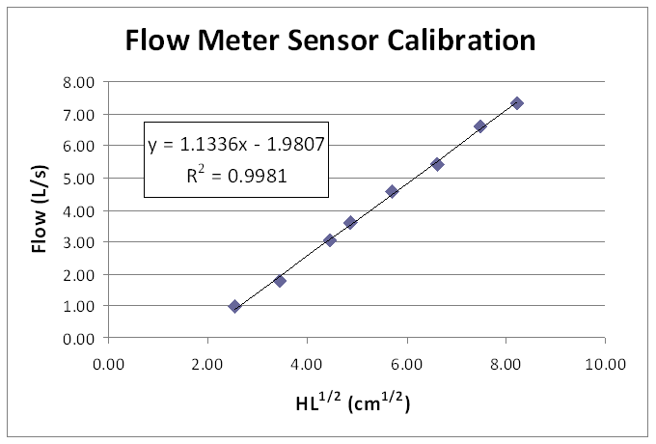
Figure 2.1. Observed flow rate versus square root of head loss across flow meter sensor.

After the process controller was set up to log data from the three new pressure sensors and the water level in the filter column was slowly raised to the level of the elevated overflow weir reached at the end of a filtration cycle, the study was conducted using ramp-up trials. All of the outlets and all but the bottom inlet valves were closed so that the entire system flow passed through the sand column from the bottom inlet up to the elevated overflow weir. The flow rate was then slowly increased using the flow control valve, and the system was allowed to run at each of the given incremental flow rates for at least a minute. At each flow rate, fluidization, or lack thereof, was observed, and the extent of bed expansion was noted. The incremental flow rates were used to determine the conditions at which bed fluidization just begins to occur.
Theoretical Predictions

Several approaches exist for theoretically predicting the fluidization velocity of a sand bed.

In the area of physical/chemical process design, a rough estimate of the incipient fluidization velocity V_{f} can be made based strictly on the settling velocity V_{S}. The empirical relationship is given by Equation 1:

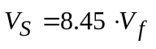 (1)

Physical/chemical process engineers can make estimates of the minimum fluidization velocity based on characteristics of the filter media. This equation includes observable characteristics of the media that are important to fluidization, but it requires a very specific and unconventional set of units: the 60th-percentile diameter, d₆₀, is in mm, the unit weights of water, ω_{s}, and filter media, ω_{m}, are in lb/ft³, and the water viscosity, μ, is in cp.

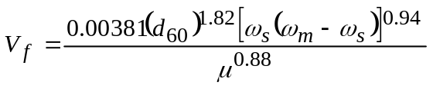 (2)

The empirical relationships in Equations 1 and 2 are used to develop parameters K_{e} and n_{e} to relate expanded-bed porosity and backwash velocity. Even if Equation 2 does not provide an insightful prediction of the incipient backwashing velocity, it would still be useful to describe the observed fluidization behavior of the sand by fitting the data to a curve of the form:

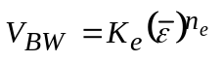 (3)

Equation 3 would then allow us to predict the expanded bed porosity ε (and therefore the degree of bed expansion) for any upflow velocity V_{BW}.

A more fundamental approach to predicting the incipient fludization velocity comes from soil engineering. Geotechnical engineers are concerned with the upward seepage of water in granular soil, because it may create “quick conditions” that cause foundations, dams, and retaining walls to fail. Like we are, they are trying to predict when the soil first begins to fluidize because of water upflow. They posit that this happens as the effective stress acting on the soil approaches zero:

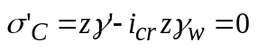 (4)

Here, γ_{w} is the unit weight of water, and γ’ is the buoyant unit weight of the soil (γ’ = γ_{Sat}– γ_{w}). This gives a critical hydraulic gradient, typically 0.9 to 1.1, for fluidization to start. Note that e is the void ratio.

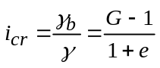 (5)

The empirical approaches in Equations 1-2 predict fluidization velocities of 32 mm/s or 5.4 mm/s, respectively, while Equation 5 predicts an incipient fluidization velocity around 5 mm/s.

Results and Discussion

After conducting six ramp-up studies, it was shown that sand fluidization began to occur at a fluid velocity of 4.8 mm/s or 416 m/day. At this minimum fluidization velocity, bed expansion was minimal. As the fluid velocity was increased above this minimum threshold, bed expansion increased. No bed expansion occurs at a fluid velocity below the minimum fluidization velocity. The observed relationship between fluid velocity and bed expansion is displayed graphically below.

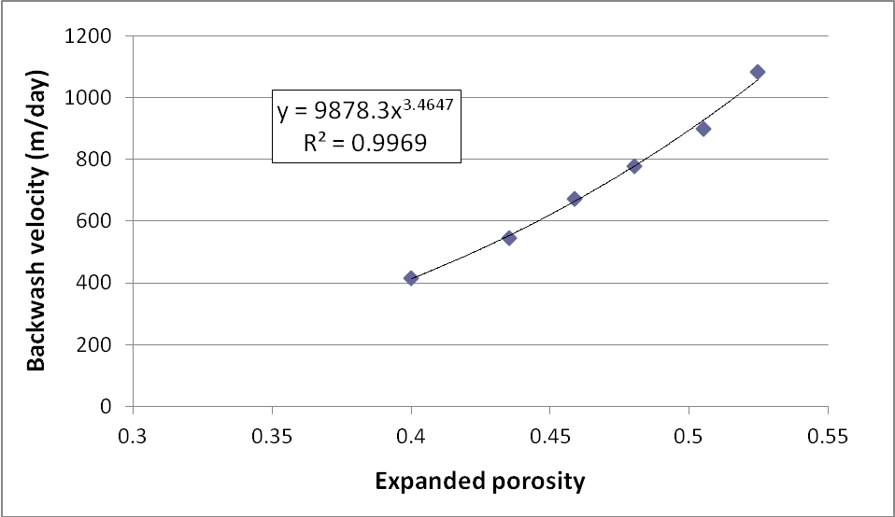
Figure 2.2. Backwash fluid velocity versus porosity of the expanded sand bed.

The figure below depicts the results of a few ramp-up tests. The upper graph shows the reading from the flow meter pressure sensor versus time, and it is annotated with the fluid velocities that correspond to the flow meter pressure sensor readings as determined by the calibration already explained. The lower graph shows the readings from the pressure sensors located at the top and bottom filter column inlets. The third line on the lower graph shows the difference between those two sensors, which is the head loss through the sand bed. In what is indicated as Test 1, the fluid velocity was ramped up from 3.5 to 5.0 mm/s, and when 5.0 mm/s was sustained, the sand fluidized. Fluidization of the sand bed is indicated by the fact that head loss through the bed only increased up to when fluidization velocity of 5.0 mm/s was sustained, and increasing the velocity beyond 5.0 mm/s did not produce any more head loss through the bed. In what is indicated as Test 2, the fluid velocity was ramped up from 4.0 to 4.8 mm/s, and when 4.8 mm/s was sustained, the sand fluidized. Again, ramping up the fluid velocity above 4.8 mm/s did not produce any more head loss through the bed.

The arrows drawn between the two graphs point to the phenomenon that has been called the pressure spike. The pressure spike is the energy required to move the packed sand column from rest into motion. It can be compared to a static friction force. Once the sand has been put into motion and fluidized, the pressure spike recedes and the head loss through the column levels off to a steady state that is insensitive to an increase in flow.

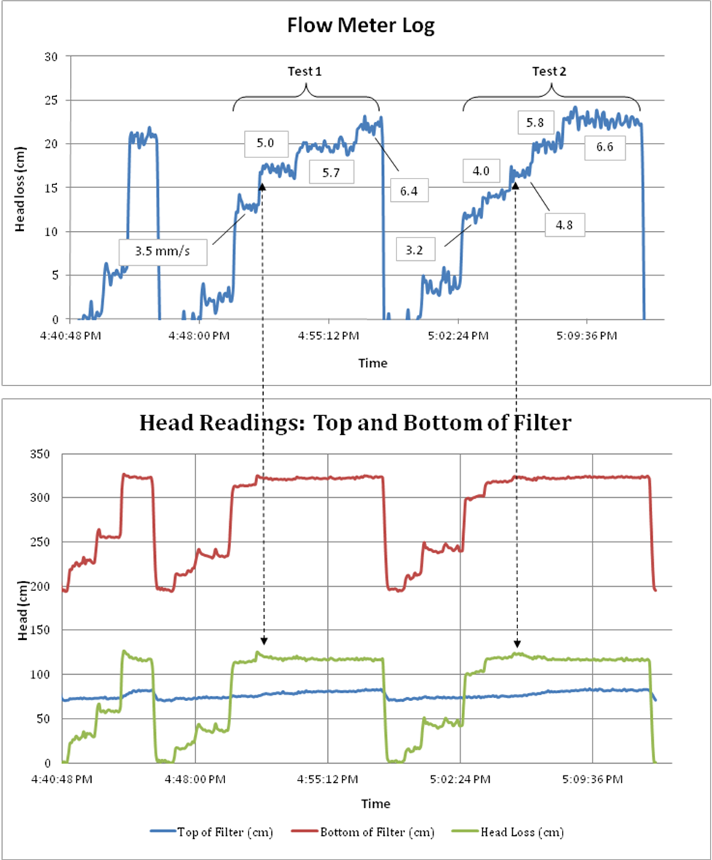
Figure 2.3. Pressure sensor logs for the flow meter and filter column. The flow meter pressure sensor was used to determine flow velocity, and the sensors in the sand bed were used to calculate the observed head loss through the filter.

Conclusions

As was the goal of the study, some important design constraints for full-scale SRSF implementation were determined by the backwash initiation study. First, it was determined that the minimum fluid velocity required to fluidize the sand bed and initiate backwash is 4.8 mm/s. Second, maintaining the fluidization of the sand bed produces 1.2 m of head loss through the bed, and this head loss is not sensitive to an increase in velocity beyond the 4.8 mm/s required to fluidize. During both loaded and clean-bed conditions, a pressure spike occurs to bring the sand from static rest into motion, so the full-scale system must provide at least a 10% factor of safety beyond the 1.2 m to ensure that enough head can be provided to overcome the pressure spike at the initiation of backwash.

Part 3: Efficient Backwash Time Studies

Procedures

The backwash time studies were run in order to observe the removal of contaminants from the filter bed during backwash, to understand the timing of solids removal, and to identify a “point of diminishing returns” for backwash. The purpose of this is to determine an efficient backwash time that can clean the filter bed and avoid degrading performance while minimizing the quantity of water used for backwash.

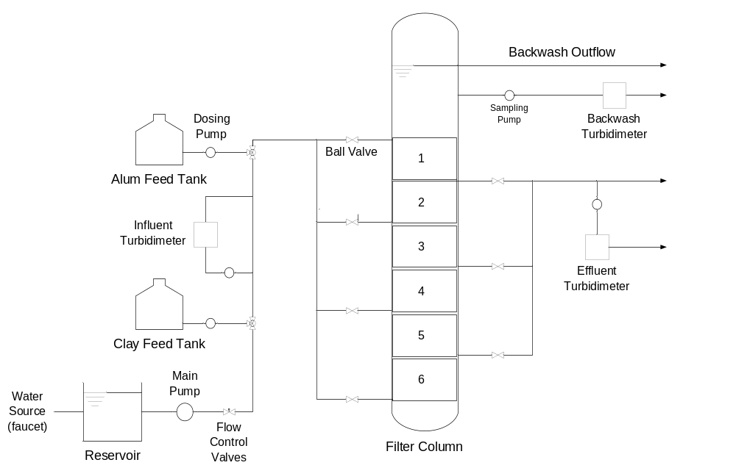
Figure 3.1. Process flow diagram of the experimental setup for the backwash time studies.
In order to complete the study a new flow control valve was put in place to regulate flow during backwash. The bench-scale filter unit, alum and clay stocks, and water source previously in place were used as shown in Figure 1. A sampling port was put in place near the backwash trough to sample the backwash water and a line was connected from the port through a sampling pump and to a turbidimeter. In order to load the bed, the filter was run at a standard influent of 5-10 NTU overnight or at an influent turbidity of 100 NTU to speed up the loading of the bed. The first backwash test indicated that the backwash effluent turbidity exceeded the turbidimeter’s maximum value of 1100 NTU and that it was necessary to dilute the backwash effluent to get it in range by mixing in tap water from the reservoir. The study also showed that it was important to use a thin sampling line to reduce settling of clay particles on the way to the turbidimeter and diminish the amount of sampling delay.

Results and Discussion

Initial results showed that the maximum backwash effluent turbidity exceeded the turbidimeter’s maximum reading capabilities. Once the dilution system was set up the expected results in Figure 2 were achieved.

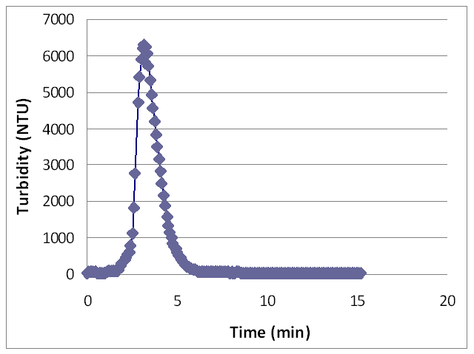
Figure 3.2. Results of a time-turbidity study with all layers fluidized at once.

A dilution factor of 9.9 was used; this was determined by measuring the turbidity of a 75 NTU stock solution and finding that its diluted turbidity was 7.6 NTU, yielding a ratio of 9.9. Figure 2 was formed by multiplying all measured values by 9.9 to yield an accurate effluent backwash turbidity. The results show that after six minutes a majority of turbidity is removed and that after that point it is no longer efficient to backwash the filter.

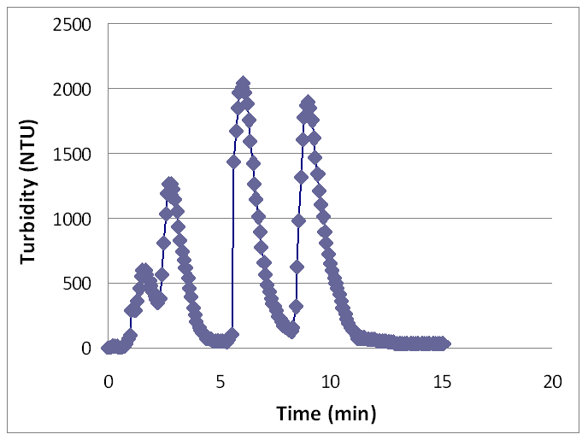
Figure 3.3. Results of a time-turbidity study with layers fluidized two at a time.

A test was then run fluidizing two layers of the bed at a time starting from the top. Figure 3 shows that as each set of layers is fludized the trend is similar to Figure 2 but in a shorter time period since there is less turbidity to remove from one set of layers.

For each backwash, the amount of turbidity removed was calculated by integrating under the backwash effluent curve:

 (1)

By evaluating the integral geometrically, Equation 1 can be simplified to Equation 2 using the sampling timestep Δt = 5 s and multiplying by each turbidity measurement NTU_{i}:

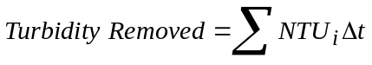 (2)

A consistent amount of clay in the range of 35,000 NTU-L was loaded into and subsequently recovered from the bed during each trial. If NTU are interpreted as a concentration unit (proportional to mg/L of clay), then NTU-L is essentially a contaminant mass.

Conclusions

This study suggests that backwash should occur for approximately six minutes in order to remove a majority of contaminants and conserve water. The study also proved the relationship between turbidity removal and time; turbidity is removed at an increasing rate until a maximum value is reached. The turbidity removal rate then decreases until steady state is reached at approximately 6 minutes.
Part 4: Control System Hydraulics

Procedures

Since the proposed control system for the full-scale SRSF is largely unproven it is important that it is demonstrated and understood before implementation. The hydraulics is one of the most uncertain pieces of the new unit process leading up to implementation this summer, so we constructed a demonstration of the hydraulics of the SRSF on the bench scale. We added the proposed SRSF hydraulic control system scaled to the flow rate of the bench-scale system, but at full vertical scale. It consists of a simulated inlet box with four vertical pipes feeding our current filter column through a series of 1/2" pipes.

The experimental setup for the control system study consists of the following steps:

- Construct a support frame for the inlet and outlet vessels, allowing for adjustment their heights
- Construct an inlet vessel with pipes at different elevations, with the vessel itself high enough to provide the head required for filtration and backwashing, containing an emergency weir and a pressure sensor to track water levels
- Connect the new inlet tubes to the filter to the current inlet pipes, using ½” hoses, hose clamps, and slip adaptors for the existing unions.
- Drill a hole in the filter column to install the siphon system that was used for the siphon study at the beginning of the semester
- Tie a vertical piece of 3” PVC pipe to the side of the filter to serve as the backwash trough, and add a weir and hose to drain the backwash water to the sink
- Construct an outlet vessel connected to the current outlet pipes using ½” hoses, hose clamps, and slip adaptors for the existing unions, containing a weir and hose to drain the filtered water to the sink and a pressure sensor to track water levels. It should be placed so that the filtration cycle water level is maintained above the siphon.

The process flow diagram in Figure 1 shows how the physical components of the system are arranged.

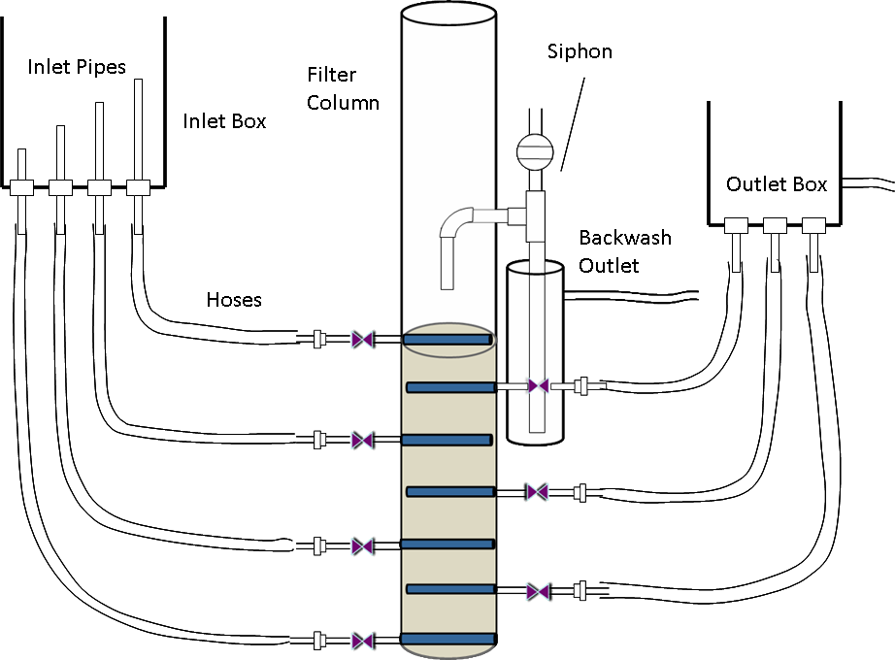

Figure 4.1. Setup of the laboratory SRSF system for a simulation of the full-scale hydraulics.

The following questions are among those that will be considered in experiments with the SRSF hydraulic controls:

- What are the important physical parameters governing the performance (and thus the design) of this system? Inlet pipes diameter? Siphon pipe diameter? Siphon valve diameter? Also, what dimensions must be selected and scaled for a full-scale design?
- What happens during the transient condition when switching from filtration into backwash? Can this be done over a period of minutes to fluidize the bed layer by layer?
- Is enough head available to fluidize the sand, even after a filter cycle?
- Will the backwash effluent channel fill with sediment? What other failure modes may be observed in this control system?
- Will sand be pulled into the backwash outlet siphon because of the high flow velocities in this pipe? What is an appropriate clear distance between this pipe and the height of the expanded sand bed?
- What are the water levels and elevations of all of the inlets and outlets? Figure 2 shows the water levels expected during each cycle.
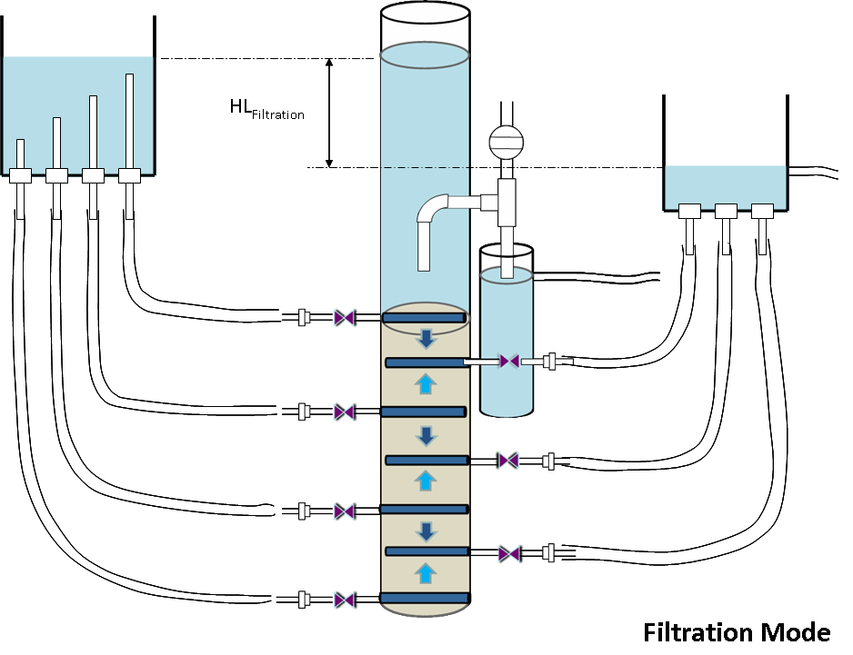

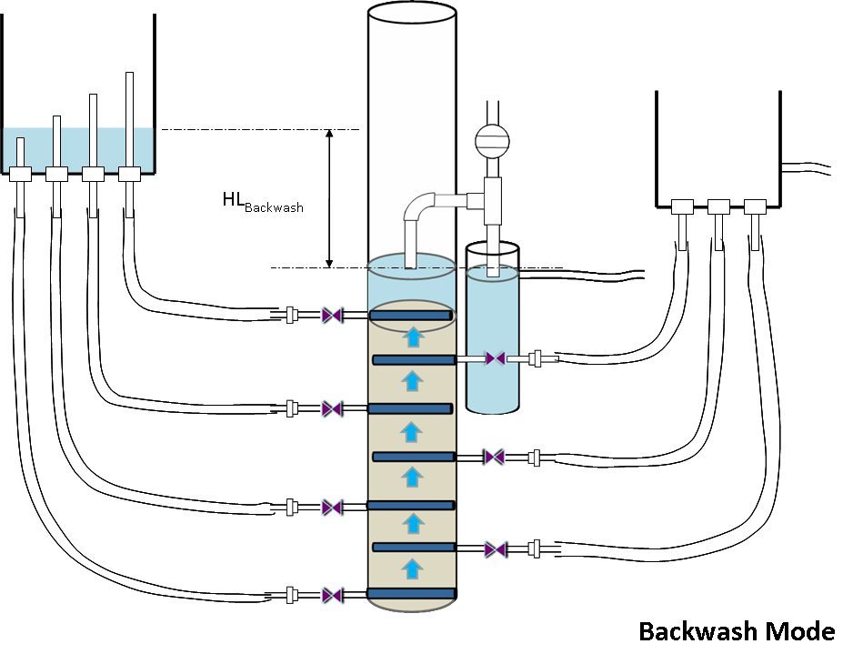

Figure 4.2. Expected water levels during the filtration and backwash cycles.

Results and Discussion

A preliminary test of the system presented us with a very important failure mode and design parameter. As we tried to run the system we encountered a failure mode in which an entire layer of sand was engulfed by the siphon system. The cause for this was inadequate space between the bottom of the siphon pipe inside of the filter and the top of the fluidized bed. The velocity of the water at the end of the pipe is magnified by the ratio of the areas of the filter and the pipe, and therefore high enough to carry sand through it. The safety factor necessary to prevent this will be explored in future tests.

As we ran the system we also realized that there is a very important parameter that was originally overlooked. The siphon was breaking at lower water levels in the filter than we had anticipated based on our previous siphon tests, and realized that the only dimension that we had changed from the old setup was the length of siphon pipe in the filter. After applying fluid statics we realized that in fact this dimension was a major constraint. At the end of backwash the water levels are as shown in Figure 3:

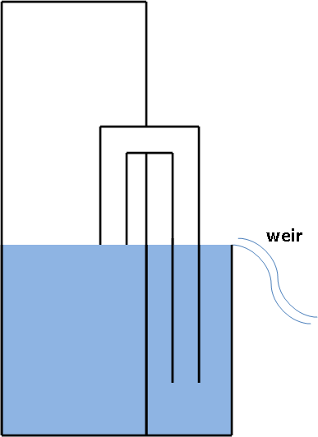

Figure 4.3. Water levels around the siphon system at the end of a backwash cycle.

Then after trapping the air in the siphon and filtering for some period of time, the water levels end up as shown in Figure 4:

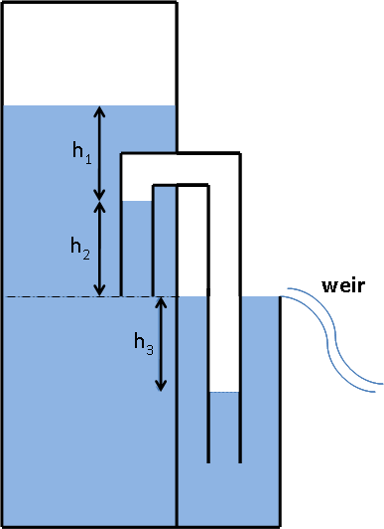

Figure 4.4. Water levels around the siphon system after some time in filtration mode.
As the water level in the filter increases, the water in the siphon tubes increases as well and subsequently displaces the trapped air. In the second figure, if assuming incompressibility, the air is just displaced from one section of the siphon to another and:

h₂ = h₃ (1)

Now assuming that the density of the air is small enough to ignore pressure changes due to change of elevation, one can assume the pressure of the air is constant throughout the siphon. So the pressure at both sides of the trapped air must be identical, which means:

h₁ = h₃ (2)

So if these Equations 1-2 hold, then we get Equation 3:

h₁ = h₂ (3)

This means that the length of the pipe of the siphon in the filter must be at least equal to the height of water above the siphon in order to maintain the siphon and prevent water from entering it. This is therefore a very important design constraint.

Conclusions

It’s too early to make conclusions at this point but after some further apparatus changes and analysis, this bench scale system can undoubtedly provide insights that are key to implementation success.

